**Task # 3 – Database Querying**

**Question#1:**

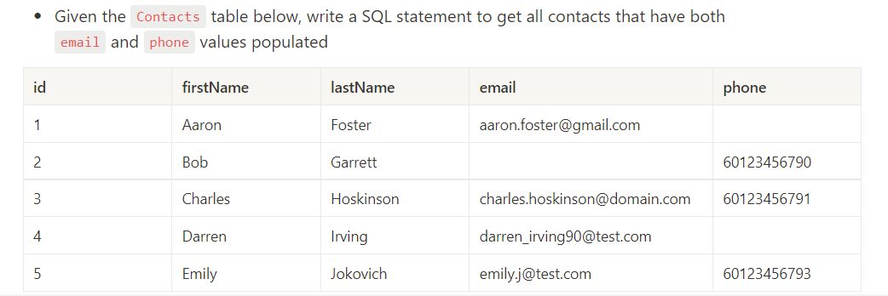

**Answer#1:**

SELECT * FROM Contacts WHERE TRIM(email)<>'' AND TRIM(phone)<>''

**Question#2:**

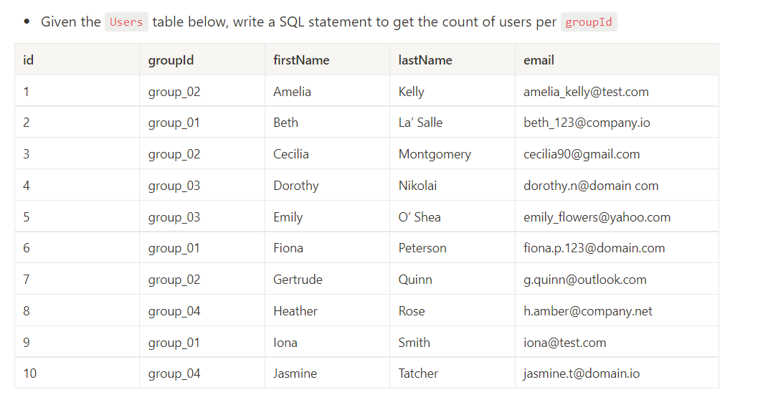

**Answer#2:**

select count(*) as UsersCount, groupId from Users Group by (groupId)

**Question#3:**

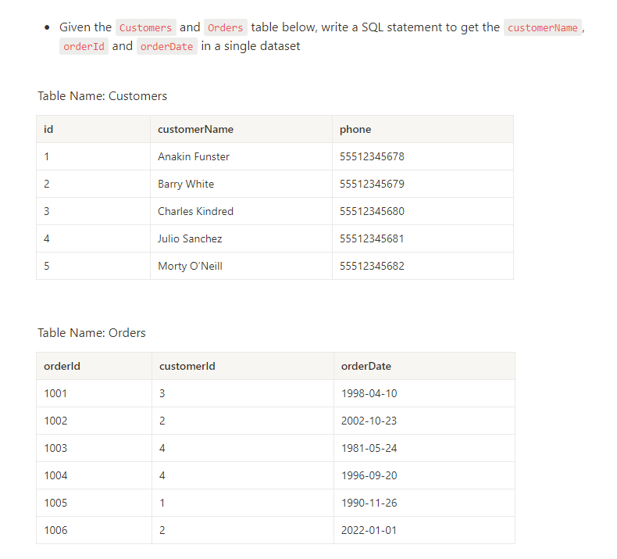

**Answer#3:**

select Customers.customerName, Orders.orderId, Orders.orderDate from Customers join Orders on Customers.id=Orders.customerId